Census Get Out the Count Toolkit for State Legislators

The 2020 Census is here! This toolkit is intended to help state legislators use their unique platforms to drive census participation in their communities. We include a list of action steps for lawmakers to get out the count and offer extensive sample digital content for legislators and staffers to directly pull, adapt, and schedule.

Feel free to email the SiX Democracy Team (democracy@stateinnovation.org) with any questions or for support.

TABLE OF CONTENTS
Strategies for Legislators to Get Out the Count 2
Social Media Content 3
Hashtags 3
Self-Response Period (March 12 to April 30) 3
Door-to-Door Follow-up Period (Mid-May to July) 6
Outreach Resources for Hard-to-Count Communities 7
Graphics 8
Blurbs for Emails, Websites & Newsletters 9
Additional Resources 10

Strategies for Legislators to Get Out the Count
State legislators have a uniquely strong platform and a responsibility to drive participation in the 2020 Census. As public officials, SiX encourages you to use your media pull, convening power, and community networks to Get Out the Count however you can.

Below are a few sample actions steps you can take to support the census from March 12 till the summer. Also check out the Census Counts Campaign’s State and Local Electeds Census Checklist.

***Note: Large constituent engagement or press activities may not be safe given the outbreak of COVID-19. Consider the below recommendations in light of what’s best for your community and the latest CDC guidance.

Traditional & Digital Media
- Promote the census on your social media platforms. [An easy must do!]
- Add a census blurb to your website and newsletter. [An easy must do!]
- Write an op-ed or letter to the editor. [SiX can help! Email democracy@stateinnovation.org]
- Organize a census press conference.
- Attend or host local census events and invite press.

Community Organizing
- Identify and support the work of your local Complete Count Committee.
- Equip community providers and centers to promote the census and job opportunities (e.g. shelters, libraries, recreation centers).

Direct Constituent Outreach
- Prepare for constituent questions. [Must do!]
- Create opportunities to speak to folks about the 2020 Census (e.g. town halls, tele-town halls).
- Request a Mobile Qualified Assistance Center to help folks fill out the census at your events (contact your local Census Bureau representative).
- Use your office to allow people to complete the census.
- Use organic opportunities at community events to connect with large groups.

Tips
- Carry census and jobs lit around with you.
- Don’t wait for a “census event” to talk about the census! Use every opportunity you have to bring up the count in your communities.

Social Media Content

Hashtags
#2020Census #ShapeYourFuture #CountUsIn #CountMeIn #WeCount #OurCount #HagaseContar #HazmeContar #YallaCountMeIn #CountAllKids

Self-Response Period (March 12 to April 30)
The 2020 Census officially begins on March 12 when the self-response period opens, and April 1 is the official census date of reference. Households will receive a mailed invitation with instructions and may self-respond anytime until the end of April. From March 12 to April 30 legislators should:
- encourage your communities to respond to the census;
- outline the response options;
- promote census jobs; and
- preempt frequently asked questions.

See below for suggested social media content to use during these weeks.

Topline Educational Messages

[For MARCH 12] Be on the lookout! Invitations to respond to the #2020Census will start hitting mailboxes in [STATE] today! For the first time, [STATE RESIDENTS, e.g. North Carolinians] can fill out their census forms online in addition to completing the form by phone or mail. Get counted early at my2020census.gov

Attention [STATE RESIDENTS, e.g. Mainers]! The #2020Census is officially underway. Take 10 minutes today to make sure your community counts and gets the resources you deserve! Visit my2020census.gov

The census is safe, important, and easy. Respond today at my2020census.gov and make sure your community counts! #2020Census

Responding to the #2020Census is fast and easy! It takes about 10 minutes and you can complete your form in one of three ways:
- Online at my2020census.gov
- By phone
- In writing

[POLL] The #2020Census is here! Have you filled out your form yet?
- Yes!
- Not yet, but I’m planning to!

Want to know more about completing the #2020Census? Check out this video guide: https://www.youtube.com/watch?v=vCM0XrSynFw&feature=emb_title

Who gets counted in the #2020Census, you ask? All [STATE RESIDENTS, e.g. Nevadans]! Including babies and toddlers, college students, active military members, renters, non-citizens, and multi-generational households. Learn more at https://2020census.gov/en/who-to-count.html

Know someone whose first language isn’t English? Let them know that the Census Bureau has bilingual assistance. Help them get counted this #2020Census so their voices can be heard.

Any questions about #2020Census? The U.S. Census Bureau has answers: https://censuscounts.org/resources-library/

Funding Messages

Did you know that by filling out the #2020Census, [STATE] can receive [$XX,XXX] over 10 years for every man, woman and child counted?

The #2020Census will impact the resources and representation [STATE] receives for 10 years … so let’s make sure to count everyone

The #2020Census is critical to our state’s future. It will help us get funding for the health care, transportation, schools, affordable housing, and higher education that our families need to be successful

***Visit George Washington University’s Counting for Dollars 2020 page to look up the funding at stake for your state.

Confidentiality & Security Messages

Responding to the #2020Census is safe. Every Census Bureau employee takes a lifetime oath to protect your data. Disclosing any information that could identify you or your family means 5 years in prison, or $250,000 in fines, or both. Get counted today!

The #2020Census is confidential, easy, and fast – your personal information is protected by law, and it takes only about ten minutes to complete the Census questionnaire. Get counted today!

The 2020 Census will NOT ask for your citizenship status. Everyone is required to
be counted by the census, including non-citizens. Stand up for your community and get counted today!

The #2020Census will never ask for your social security number, bank or credit card information, or money. If a form or enumerator asks for any of this, it’s a scam! Report suspected fraud to the Census Bureau at 800-923-8282.

Jobs Messages  It's not too late to apply for a temporary part-time position with the #2020Census! Apply to earn extra income and help your community. Visit 2020census.gov/jobs  Looking for flexible part-time work that will benefit your community? Apply for a job with the #2020Census! Pay starts at $[XX]/hour in [STATE/COMMUNITY]. Apply at 2020census.gov/jobs  The #2020Census needs bilingual workers! Help your community count and apply today at 2020census.gov/jobs. The hours are flexible and pay starts at $[XX]/hour!  ***Check the census pay in your area at: https://2020census.gov/en/jobs/pay-and-locations.html | Example: NV Asm. Howard Watts  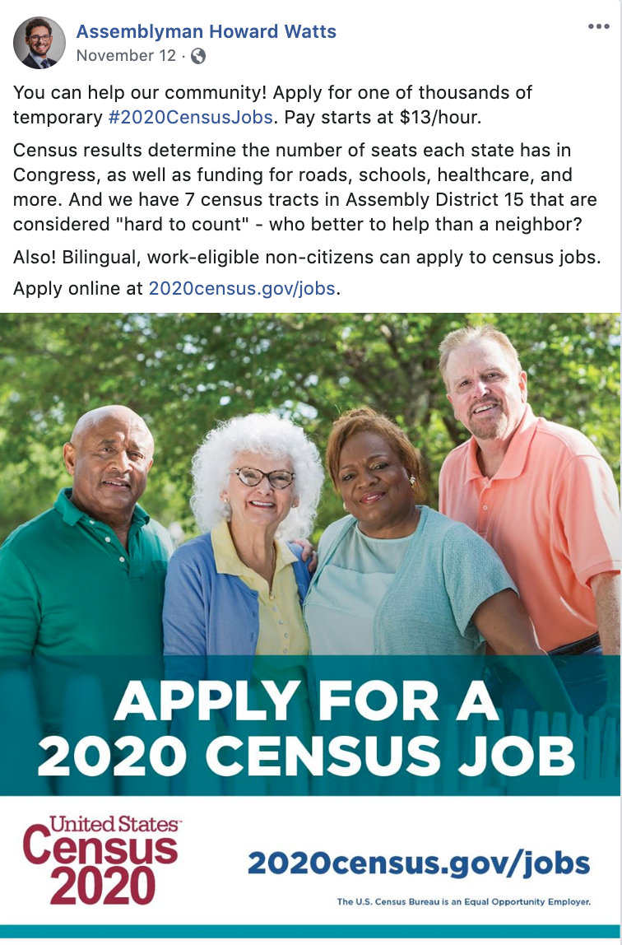

Door-to-Door Follow-up Period (Mid-May to July)
During this window, Census Bureau enumerators will go door-to-door following up with households that did not self-respond. Your messages should encourage cooperation and emphasize safety.

See sample social media content for this period below.

If were unable to fill out the #2020Census last month, expect a knock at your door from a friendly, local census taker!

Heads up [RESIDENTS, e.g. Michiganders]! #2020Census enumerators will be in our community over the next few weeks. If you didn’t respond to the census, expect a knock on your door from a credentialed enumerator. They’ll ask you a few basic questions which will help [STATE] get funding for important public services for the next 10 years.

The #2020Census will never ask for your social security number, bank or credit card information, or money. If a form or enumerator asks for any of this, it’s a scam! Report suspected fraud to the Census Bureau at 800-923-8282.

Census enumerators are in our community making sure that all [STATE RESIDENTS] count! If someone visits your home to collect a response for the #2020Census, you can do the following to verify their identity:
- Check that they have a valid ID badge, with their photograph, a U.S. Department of Commerce watermark, and an expiration date.
- If you still have questions about their identity, call 800-923-8282 to speak with a local Census Bureau representative.

Outreach Resources for Hard-to-Count Communities
Advocates representing Black, Brown, Indigenous, LGBTQ, and other hard-to-count communities have undertaken deep messaging research to mobilize all people to respond to the 2020 Census.

Check out the below list of resources to tailor and strengthen your social media content to reach hard-to-count folks in your state.

Black Communities, Color of Change
- Hashtag: #OurCount
- Get Out The Count: A Toolkit for Census Advocates (includes social media posts tailored to mobilize census participation in Black communities)
- Our Count Social Media Graphics (extensive bank of graphics for census mobilization)
- Our Count Campaign Homepage

Latinx Communities, NALEO Education Fund
- Hashtags: #HagaseContar and #HazmeContar
- 2020 Census Communications Toolkit
- ¡Hazme Contar! Social Media Posts
- ¡Hágase Contar! Campaign Homepage
- ¡Hazme Contar! Campaign Homepage (for Latinx children)

AAPI Communities, Asian Americans Advancing Justice
- Hashtag: #CountUsIn2020
- 2020 GOTC Community Engagement and Communications Toolkit (soon to be available in multiple languages)
- Count Us In Campaign Homepage

Arab American Communities, Arab American Institute
- Hashtag: #YallaCountMeIn
- 2020 Census Arab American Toolkit (includes tailored digital content to mobilize Arab American census participation)
- Social Media Shareables
- Yalla Count Me In! Campaign Homepage

Native and Indigenous Communities, National Congress of American Indians
- Indian Country Counts 2020 Census Toolkit
- Indian Country Counts Campaign Homepage (NCAI Homepage)
- Natives Count Campaign Homepage

Young Children and Parents, Count All Kids & Sesame Workshop
- Hashtag: #CountAllKids
- Count All Kids Toolkit
- Sesame Workshop 2020 Census Toolkit (includes videos, social media graphics, and posters)
- 2019 Grandparents Day Census Social Media Toolkit
- Count All Kids Campaign Homepage
- Clearinghouse of Resources to Encourage Counting All Kids

LGBTQ Communities, National LGBTQ Taskforce
- Queer the Census Campaign Homepage

Graphics
Post SiX’s census graphic and use this link to update your Facebook profile frame.

Also browse:
- US Census Bureau: Social Media Graphics
- Color of Change: OurCount Social Media Graphics
- Asian Americans Advancing Justice: 2020 Census Social Media Graphics folder

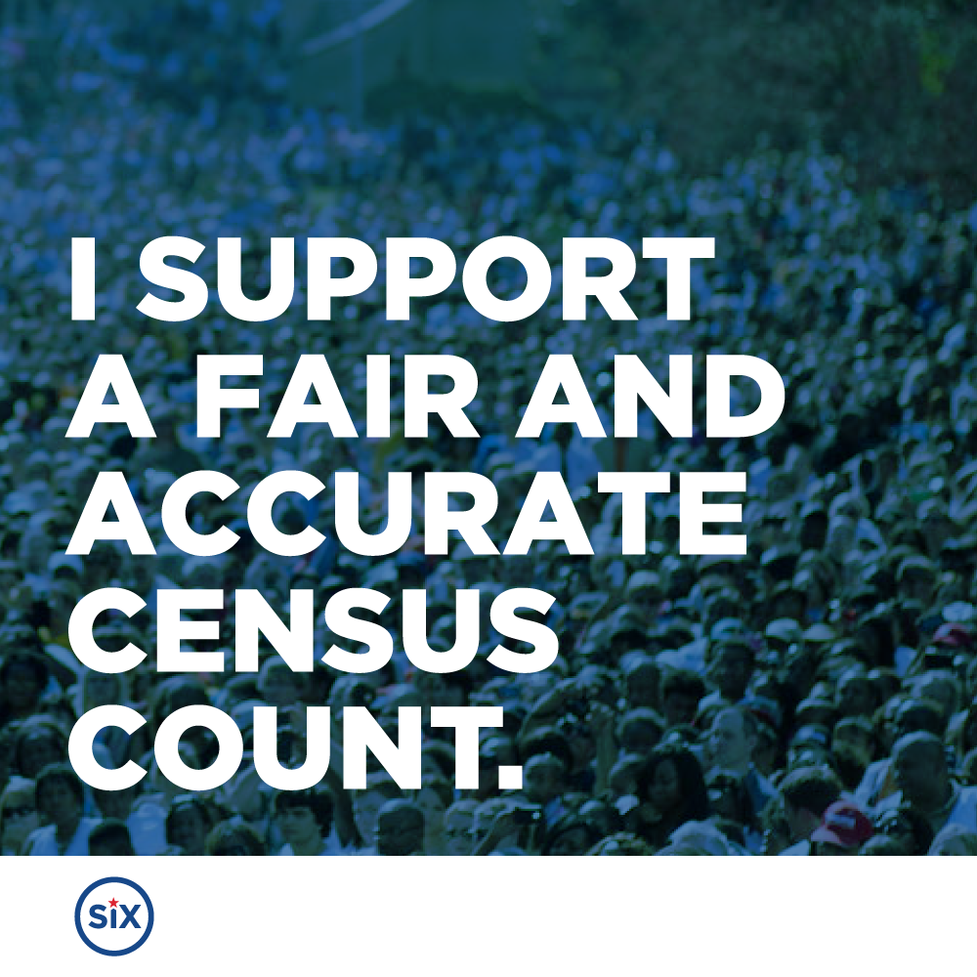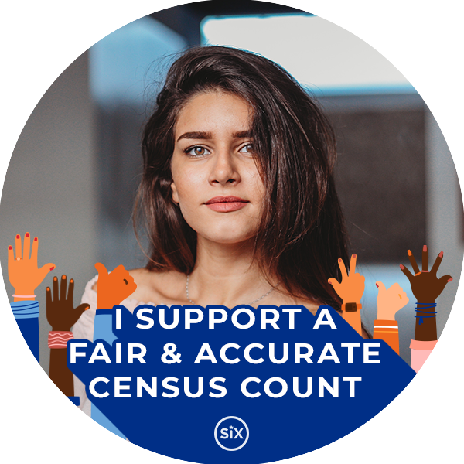

Blurbs for Emails, Websites & Newsletters
Here are two descriptions of why the census matters that you can add to your email signature, website, newsletter, and other ways you communicate with your constituents.

The 2020 Census is happening now! Take 10 minutes to make sure you and your community get counted by visiting my2020census.gov.
A complete and accurate 2020 Census ensures that [STATE/COMMUNITY] gets the resources and representation we deserve. For each person counted in the census, our communities get funding for crucial services like health care, transportation, schools, child care, and affordable housing. We need each and every [STATE RESIDENT, e.g. Georgian] to count! This includes citizens and noncitizens, newborns and seniors, documented and undocumented, and homeowners, renters, and homeless persons. Filling out the 2020 Census is safe and your data is protected by strict confidentiality laws. It’s also incredibly convenient. You can fill out the census online (visit my2020census.gov), by phone, or on paper. Check your mail for the instructions or visit the U.S. Census Bureau website for more information!

Responding to the 2020 Census is safe, important, and easier than ever! Visit my2020census.gov to respond online.
Be on the lookout: Invitations to respond to the 2020 Census will start hitting mailboxes in [STATE/LOCALITY] on March 12. For the first time, [STATE RESIDENTS, e.g. North Carolinians] will have the opportunity to fill out their census forms online in addition to completing the form by phone or mail.

Completing the 2020 Census is a critically important civic duty that determines federal funding for public safety, schools, housing, health care and other essential services. It shapes our representation in Congress, and much more. It’s important everyone in [STATE/LOCALITY] be counted because census numbers affect everyone from seniors to students, kids and parents, businesses and communities.

Remember, being counted in the census is as important as voting is to our democracy and is part of our responsibility as residents of the United States. To learn more about the 2020 Census, visit: [STATE CENSUS PAGE or https://2020census.gov/en/ways-to-respond.html]

***The second blurb was adapted from a newsletter by Delhi Township, Michigan.

Additional Resources
State Innovation Exchange
- Webinar Recording: Supporting the 2020 Census as a Legislator (Includes an operational overview, messaging guidance, and action steps for legislators. Delivered for state legislators and staffers in Florida in partnership with KIDS Count FL.)
- Webinar Recording: Elected Officials 2020 Census Webinar
- Preparing for the 2020 Census: How State Legislators Can Ensure That Every Person Counts (Co-authored by Common Cause and the Leadership Conference.)

U.S. Census Bureau
- Outreach Materials Homepage
- Community Outreach Toolkit
- 2020 Census Partner Social Media Content
- 2020 Census Program Resources (Includes links to language resources, promotional materials, and operational plans.)

Census Counts Campaign
- State and Local Electeds Census Checklist
- Get Out The Count Planning Worksheet
- Census Champions Network
- Census Counts Campaign Resource Bank

Hard to Count Communities Map

